Technical Architecture:

Project Design Phase-II Technology Stack (Architecture & Stack)

|  |  |
| --- | --- |
| Date | 12 October 2022 |
| Team ID | PNT2022TMID22202 |
| Project Name | Project – A new hint to transportation –  Analysis of the NYC bike share system |
| Maximum Marks | 4 Marks |

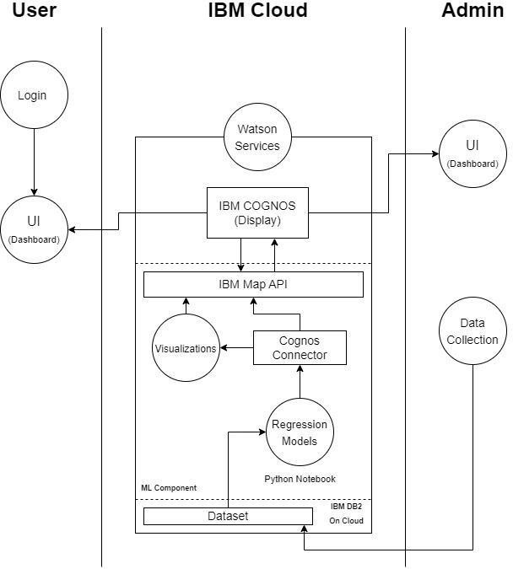

Table-1 : Components & Technologies:

|  |  |  |  |
| --- | --- | --- | --- |
| **S.No** | **Component** | **Description** | **Technology** |
| 1. | User Interface - 1 | 1. Display results of analysis as visualizations to user 2. Display insights obtained after data analysis | HTML, CSS, JavaScript, React JS, IBM Cognos, etc. |
| 2. | Application Logic-1 | Logic for a process in the application | Java / Python |
| 3. | Database | To store the memory intensive Citi bike dataset | MySQL, MongoDB, etc. |
| 4. | Cloud Database | To store the memory intensive Citi bike dataset on Cloud | IBM DB2, IBM Cloudant etc. |
| 5. | File Storage | File storage requirements | IBM Block Storage or Other Storage Service or Local Filesystem |
| 6. | External API-1 | To obtain geospatial information of Citi bike in NYC and map it | IBM Map API |
| 7. | External API-2 | To perform analysis | Google Colab, Jupyter Notebook |
| 8. | Machine Learning Model | 1. To help predict results / values for new incoming data 2. To plot graphs based on dataset | Regression Models |
| 9. | Infrastructure (Server / Cloud) | Application Deployment on Local System / Cloud Local Server Configuration: Local Server (localhost) Cloud Server Configuration : IBM Cloud | Local, Cloud Foundry, Kubernetes, etc. |

Table-2: Application Characteristics:

|  |  |  |  |
| --- | --- | --- | --- |
| **S.No** | **Characteristics** | **Description** | **Technology** |
| 1. | Security Implementations | Encrypting login credentials of users | e.g. SHA-256, Encryptions, IAM Controls, OWASP etc. |
| 2. | Scalable Architecture | Each IBM Cognos BI server contains a dispatcher that runs the IBM Cognos BI presentation service, batch report and report services, job and schedule monitor service, and log  service. | IBM Cognos BI Server scalability |
| 3. | Availability | All Web communication in IBM Cognos BI is through an IBM Cognos BI gateway installed on a Web server. Each gateway can communicate with a single dispatcher in the applications tier.  The IBM Cognos Business Intelligence server contains Content Manager to store and manage information, and a dispatcher to start IBM Cognos services and route requests.  Content Manager writes to the content store RDBMS using proper relational transactions. Standard DB tools can be  used for backing up and restoring the content store. | IBM Cognos BI gateway, dispatchers, etc. |
| 4. | Performance | Size of data to be analysed is very large | IBM Cognos content store |